The entity-relationship data model

Conceptual modelling

Overview of database design process
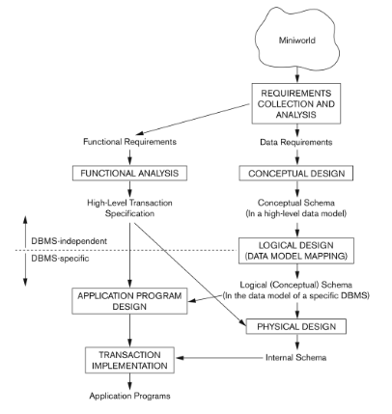
Two main activities:
- Database design
- Applications design
Focus on database design here
- To design the conceptual schema for a database application
Applications design focuses on the programs and interfaces that access the database
- Generally considered part of software engineering.

Example company database
We need to create a database schema design based on the following (simplified) requirements of the COMPANY database:
- The company is organised into DEPARTMENTs. Each department has a name, number and an employee who manages the department. We keep track of the start date of the department manager. A department may have several locations.
- Each department controls a number of PROJECTs. Each project has a unique name, unique number and is located at a single location.
- We store each EMPLOYEE social security number, address, salary, gender and birthdate.
  - Each employee works for one department but may work on several projects.
  - We keep track of the number of hours per week that an employee currently works on each project
  - We also keep track of the direct supervisor of each employee.
- Each employee may have a number of DEPENDENTs.
  - For each dependent, we keep track of their name, sex, birthdate, and relationship to the employee.
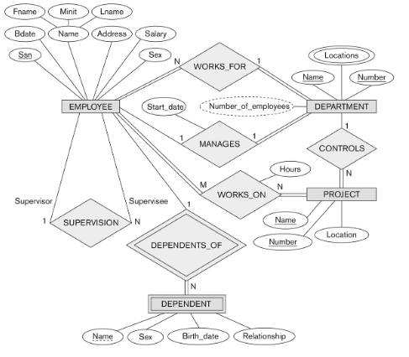

(how do we derive this?...)

Entities and attributes in the er data model
Based on the previous specification of a mini-world, we define the conceptual model based on Entity-Relationship principles
- An Entity-Relationship model has three main concepts:
- Entities (and their entity types and entity sets)
- Attributes (simple, composite, single-valued, multi-valued)
- Relationships (and their relationship types and relationship sets).
Entities are specific objects or things in the mini-world that are represented in the database.

Entities
Entities are specific objects or things in the mini-world that are represented in the database
For example:
- The EMPLOYEE John Smith
- The Research DEPARTMENT
- The ProductX PROJECT
Entities may be either physical (employees) or non-physical objects (projects)

Attributes
Attributes are properties used to describe an entity
- An EMPLOYEE entity may have the attributes Name, SSN, Address, BirthDate, etc.
A specific entry will have a value for each of its attributes
- A specific employee may have the Name=’John Smith’, etc.
Each attribute has a value set (or data type) associated with it, e.g. integer, string, date.

Types of attributes
Simple Attribute
- Each entity has an atomic (non-divisible) value for this attribute
- For example: Employee Social Security Number (SSN)
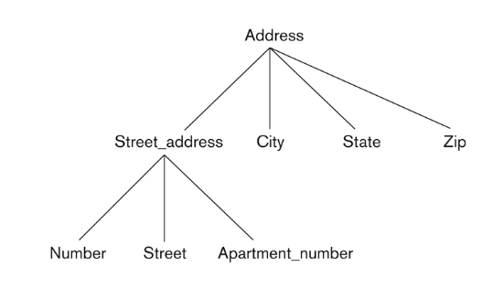
Composite
- The attribute may be composed of several components
- For example:
  - Address(Apt#, House#, …)
  - Name (FirstName, MiddleName, LastName).
Single-valued
- Each entity can have a single value for this attribute
- For example: the “Age” attribute for each EMPLOYEE entity
Multi-valued
- An entity may have multiple values for that attribute
- For example: Colour of a CAR Entity or PreviousDegrees of a STUDENT.
- Denoted as {Colour} or {PreviousDegrees}
An attribute can be both composite and multi-valued.
For example, PreviousDegrees of a STUDENT is a composite and multi-valued attribute
- Denoted by {PreviousDegrees (College, Year, Degree, Field)}
Multiple PreviousDegrees values can exist
- Each degree has four subcomponent attributes
  - College, Year, Degree, Field

Entity Types and key attributes
Entities with the same basic attributes are grouped or typed into an entity type.
- For example, the entity type EMPLOYEE and PROJECT
An attribute of an entity type for which each entity must always have a unique value that is called a key attribute of the entity type.
- For example, SSN of EMPLOYEE
A key attribute must be composite.
- Example (from US car IDs):
  - VehicleTagNumber is a key of the CAR entity type with components (Number, State)
An entity type may have more than one key attribute
- The CAR entity type may have two keys:
- VehicleIdentificationNumber (popularly called VIN)
- VehicleTagNumber (Number, State) or licensed plate number.
Each key attribute is underlined in the ER diagram.

Displaying an entity type
In ER diagrams, an entity type is displayed in a rectangular box.
Attributes are displayed in ovals.
- Each attribute is connected to its entity type
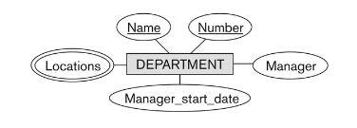
- Components of a composite attribute are connected to the oval representing the composite attribute
- Each key attribute is underlined
- Multivalued attributes displayed in double ovals.
Entity type car with two keys and a corresponding entity set:
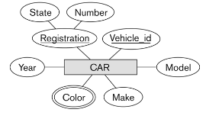
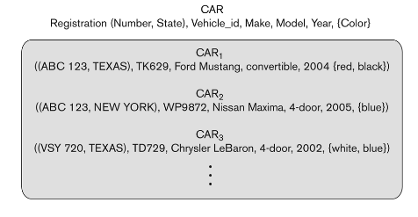

Entity set
Each entity type will have a collection of entities stored in the database
- Called the entity set
Three car entity instances in the entity set for CAR are shown
Same name (CAR) used to refer to both the entity type and the entity set
Entity set is the current state of the entities of that type that are stored in the database.

Initial design of entity types
Based on the requirements, we can identify four initial entity types in the COMPANY database:
- DEPARTMENT
- PROJECT
- EMPLOYEE
- DEPENDENT
The initial attributes are derived from the requirements description
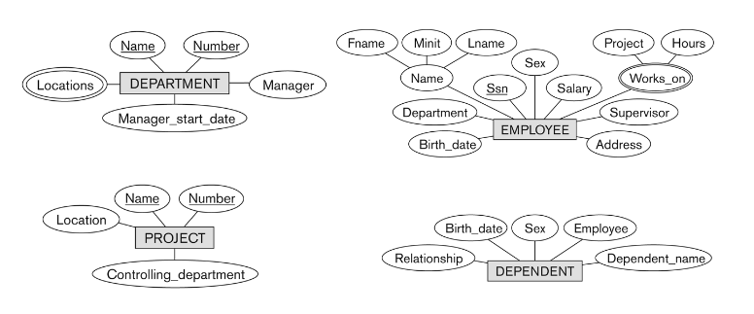

Relationships
A relationship relates two or more distinct entities with a specific meaning
- For example:
  - EMPLOYEE John Smith works on the ProductX PROJECT
Relationships of the same type are grouped or typed into a relationship type
- For example:
  - the WORKS_ON relationship type in which EMPLOYEEs and PROJECTs participate
The degree of a relationship type is the number of participating entity types
- WORKS_ON is a binary relationship.

Relationship type vs relationship set
Relationship Type:
- A set of associations among entities
- The schema description of a relationship
- Identifies the relationship name and the participating entity types
- Also identifies certain relationship constraints
Relationship Set:
- The current set of relationship instances represented in the database
- The current state of a relationship type
In ER diagrams, we represent the relationship type as follows:
- Diamond-shaped box is used to display a relationship type
- Connected to the participating entity types via straight lines

Company database requirements
- An employee manages the department
- A department controls a number of projects
- An employee works for one department, but may work on several projects. Each employee has a direct supervisor.
- Each employee may have a number of dependents.

By examining the requirements, six relationship types are identified:
- WORKS_FOR (between EMPLOYEE, DEPARTMENT)
- MANAGES (also between EMPLOYEE, DEPARTMENT)
- CONTROLS (between DEPARTMENT, PROJECT)
- WORKS_ON (between EMPLOYEE, PROJECT)
- SUPERVISION (between EMPLOYEE (as subordinate), EMPLOYEE (as supervisor))
- DEPENDENTS_OF (between EMPLOYEE, DEPENDENT)
Most are binary relationships, apart from SUPERVISION, that is unary.
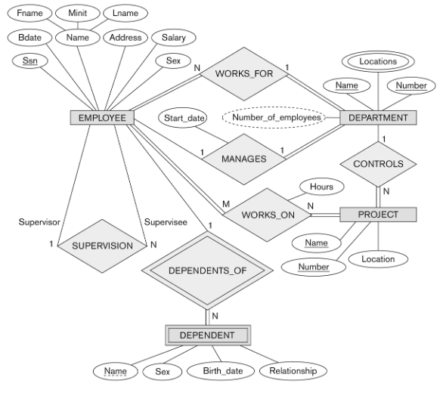

Discussion on relationship types
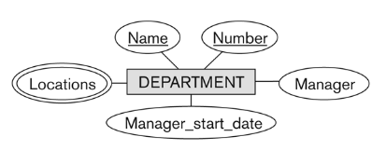
In the refined design, some attributes from the initial entity types are refined into relationships:
- Manager of DEPARTMENT → MANAGES
- Works_on of EMPLOYEE → WORKS_ON
- Department of EMPLOYEE → WORKS_FOR
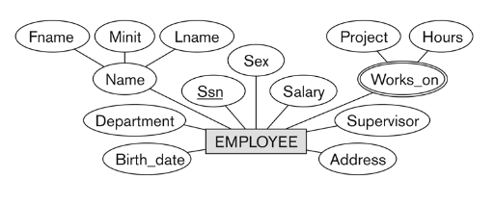

In general, more than one relationship type can exist between the same participating entity types.
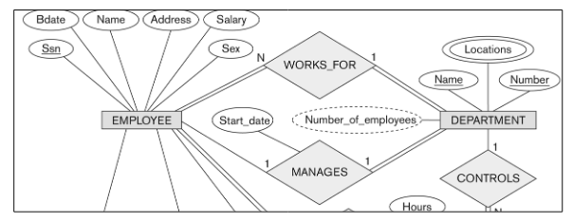
- MANAGES and WORKS _FOR are distinct relationship types between EMPLOYEE and DEPARTMENT
- Different meanings and different relationship instances

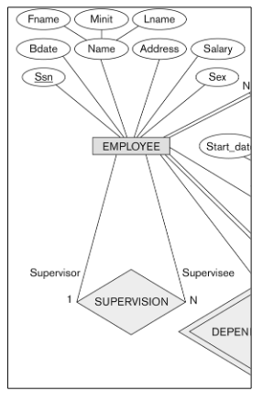
Recursive relationship type
- A relationship type with the same participating entity type in distinct roles, e.g. the SUPERVISION relationship.
- EMPLOYEE participates twice in two distinct roles:
  - Supervisor role
  - Supervisee role
- Each relationship instance relates two distinct EMPLOYEE entities:
  - One employee in supervisor role
  - One employee in supervisee role

Displaying a Recursive Relationship
In a recursive relationship type:
- Both participations are the same entity type in different roles
e.g.: SUPERVISION relationships between EMPLOYEE in role of supervisor and another EMPLOYEE in role of subordinate
In the figure, first role participation labelled with ‘Supervisor’ and second role participation labelled with ‘Supervisee’.
In ER diagrams, you need to display role names to distinguish participations.

Weak Entity Types
An entity that does not have a key attribute is a weak entity type.
- A weak entity must participate in an identifying relationship type with an owner or identifying entity type.
- Entities are identified by the combination of:
  - The particular entity they are related to in the identifying entity type
  - A partial key: an attribute that can uniquely identify weak entities that are related to the same owner entity.
- For example:
  - DEPENDENT is a weak entity type.
  - A DEPENDENT entity is identified by the dependent’s first name and the specific EMPLOYEE with whom the dependent is related
  - EMPLOYEE is its identifying entity type via the identifying relationship type DEPENDENT_OF
  - Name of DEPENDENT is the partial key.
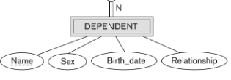

Structural constraints of relationships
Structural constraints on relationship types are also known as ratio constraints.
- Cardinality Ratio: specifies maximum number of relationship instances that an entity can participate in.
  - One-to-one (1:1)
  - One-to-many (1:N) or Many-to-one (N:1)
  - Many-to-many (M:N)
- Existence Dependency Constraint: specifies minimum participation of an entity in a relationship, i.e. if existence of an entity depends on it being related to another entity via relationship type (also called participation constraint)
  - zero (optional participation, not existence-dependent)
  - one or more (mandatory participation, existence-dependent)

Notation
- Cardinality ratio (of a binary relationship): 1:1, 1:N, N:1, or M:N
  - Shown by placing appropriate numbers on the relationship edges
- Participation constraint (on each participating entity type)
  - total (called existence dependency) showed by double line
  - partial shown by single line
Each instance of a relationship set relates individual participating entities, one from each participating entity type.
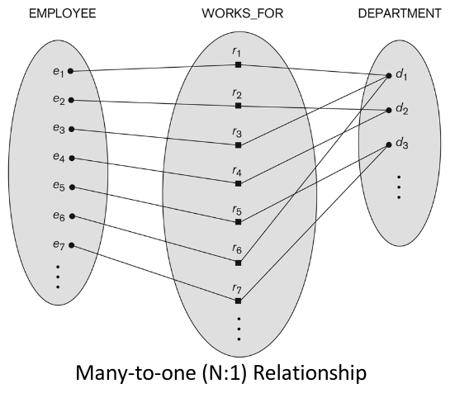
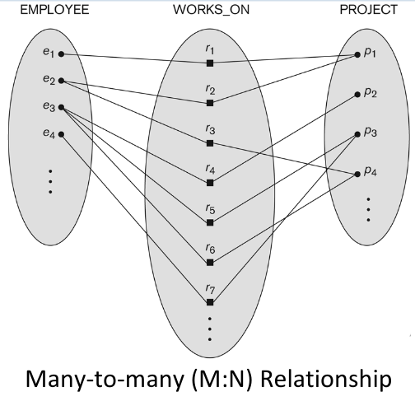

Alternative notation for relationships
Structural Constraints:
- Specified on each participation of an entity type E in a relationship type R
- Specifies that each entity e in E participates in at least min and at most max relationship instances in R
- Default(no constraint): min = 0, max = n (signifying no limit)
- Must have min<= max, min >= 0, max >= 1
- Derived from the knowledge of mini-world constraints.
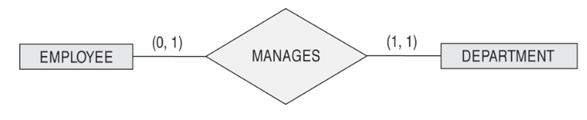
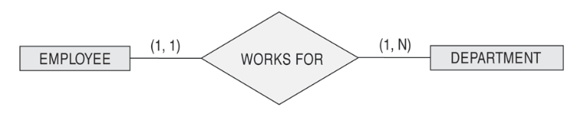

Displaying a recursive relationship
In figure, first role participation labelled with 1 and second role participation labelled with 2
- In ER diagram, need to display role names to distinguish participations.
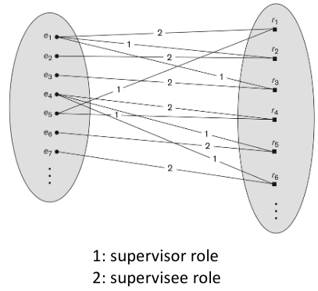

A relationship type can have attributes:
- e.g. HoursPerWeek of WORKS_ON
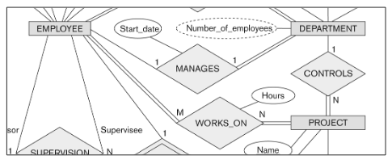
- Its value for each relationship instance describes the number of hours per week that an EMPLOYEE works on a PROJECT
- Most relationship attributes are used with M:N relationships

Summary
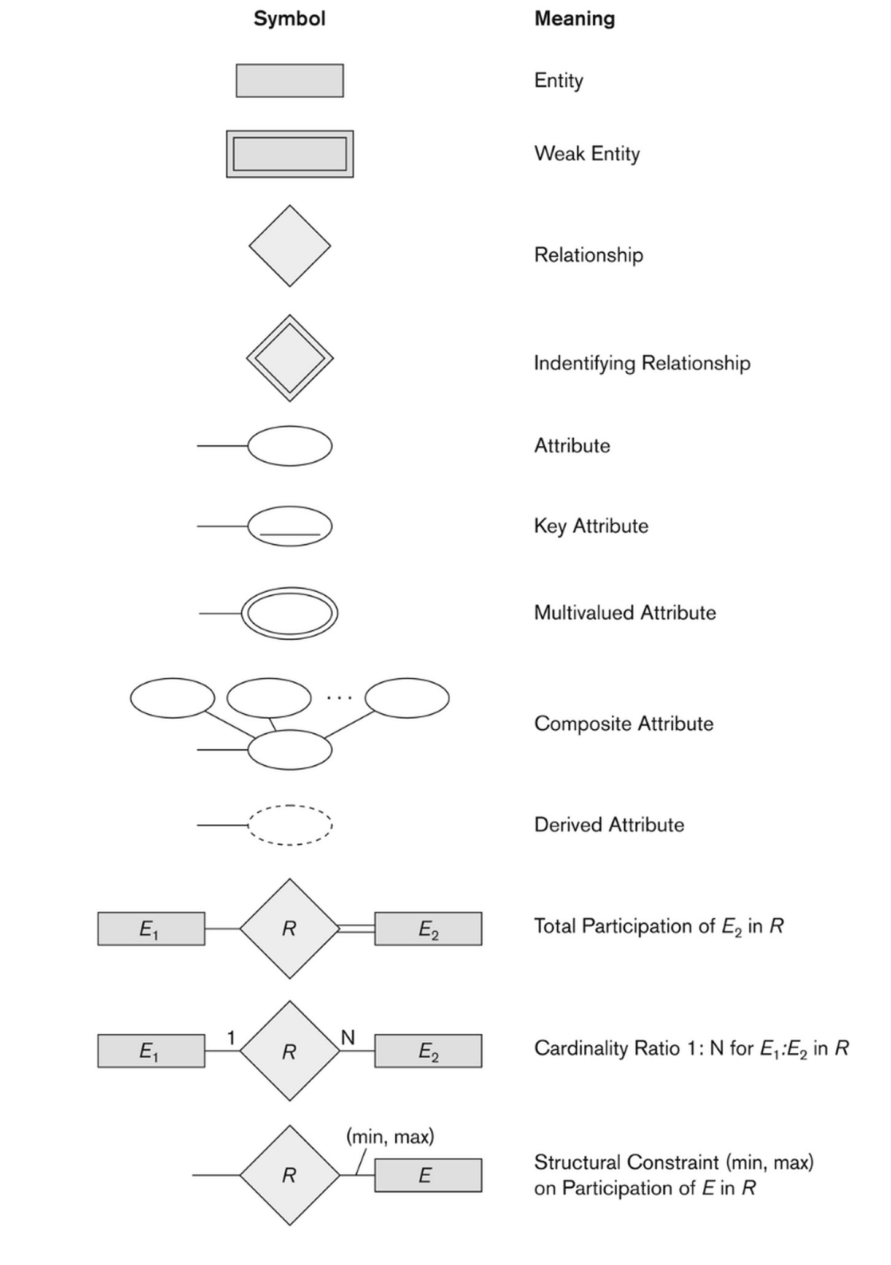

Relationships of higher degree
- Relationship types of degree n are called n-ary.
- In general, an n-ary relationship is not equivalent to binary relationships.
- Constraints are harder to specify for higher-degree relationships (n > 2) than for binary relationships.

Alternative diagrammatic notation
- ER diagrams is a popular means for displaying database schemas
- Many other notations exist in the literature and in various database design and modelling tools.
- UML class diagrams is representative of another way of displaying ER concepts that is used in several commercial design tools

UML
Represent classes (similar to entity types) as large boxes with three sections:
- Top section includes entity type (class) name
- Second section includes attributes
- Third section includes class operations (operations are not in basic ER model)
Relationships (called associations) represented as lines connecting the classes
- Other UML terminology also differs from ER terminology
Used in database design and object-oriented software design
UML has many other types of diagrams for software design.
